Match the festivals with the country.

1. 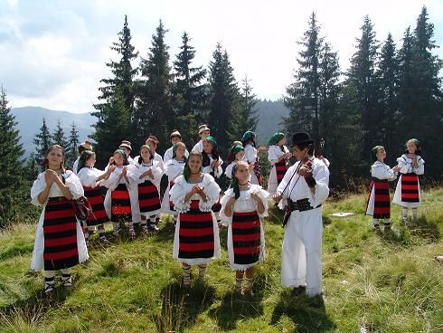 Prislop Festival, Maramures
2. Romania
3. Bulgaria
4. Turkey
5. Italy

Answer: a

1. 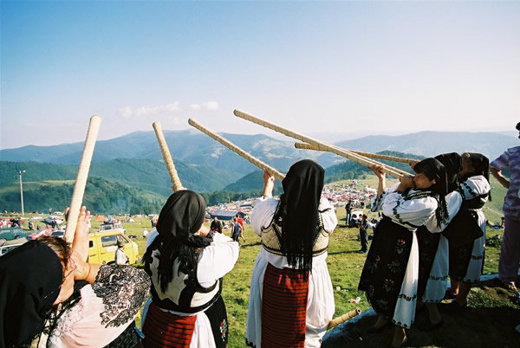 Mount Gaina Maidens’ Fair
2. Bulgaria
3. Italy
4. Spain
5. Romania

Answer: d

1. 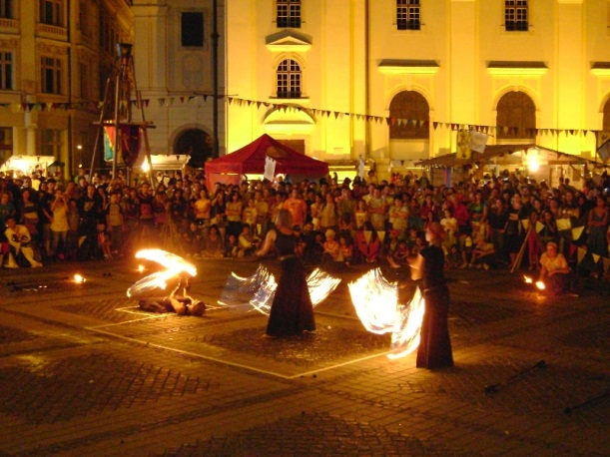 The Sibiu Medieval Festival
2. Bulgaria
3. Poland
4. Romania
5. Spain

Answer: c

1. 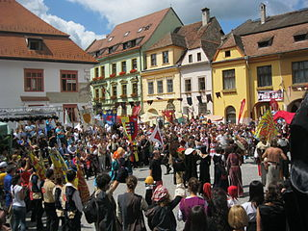 The Sighisoara Festival of Medieval Arts and Crafts
2. Poland
3. Bulgaria
4. Italy
5. Romania

Answer: d

1. 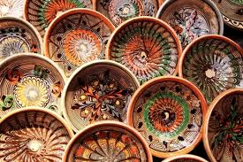 The Horezu ceramics fair
2. Spain
3. Italy
4. Turkey
5. Romania

Answer: d